- Connect cables to power supplies
  - 3x 4139 cables, 1x 4163 cable
- Connect 1 HMC sig gens
- Connect the RF connections as follows in the diagram
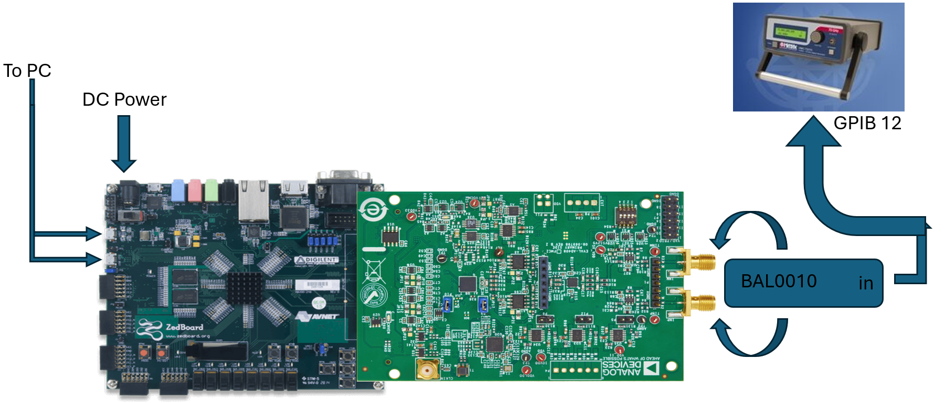

- Connect the banana jacks as follows
- Be sure to connect all ground connections together.
Black GND | GND connections
Red 3.3v VDD | 4 VCC (4139 card)
Orange 1.5v VIO | 5 VCC (4139 card)
Yellow 1.1v VDDLDO | 6 VCC (4139 card)
Green 1.1v VDD
- Open the Labview software
  - Configure the Data block as necessary
- Open the power block
Be sure to activate all channels and queue the changes
  - Slot_4
    - Voltage = 3.3v, channel name = Red 5v VDD
  - Slot_5
    - Voltage = 1.5v, channel name = Orange 3.3v VIO
  - Slot_6
    - Voltage = 1.1v, channel name = Yellow 1.8v VDDLDO
  - Slot_3
    - Voltage = 1.1v, channel name = Green 1.1v VDD
- Open the RF Block
  - GPIB 12
    - Name = RF_IN, Freq = 1MHz, Power = 0dBm
- Check unconfigured Supply Currents
- Note! If the part is pre-configured this could be different, see the configured supply currents if this doesn’t match.
Red 5v VDD | Orange 3.3v VIO | Yellow 1.8v VDDLDO | Green 1.1v VDD

- Open the script AD4080_SEE at C:\Git\pyadi-iio\examples\Radiation Testing
- Run the script
- Note the configured Supply Currents
Red 5v VDD | Orange 3.3v VIO | Yellow 1.8v VDDLDO | Green 1.1v VDD

